World Book Day Competition!
Create inspirational AI-generated artwork 🖥️

Hey everyone! 👋 This World Book Day, you’re going to become a book artist! 🎉
Entries start now. The final day for entries is [date]

Type a prompt into an AI image generator to create an image of someone
reading in the most imaginative and extreme place possible.

E.g. “A kid reading a book on an imaginary planet sitting in
a crater with alien friends, three suns and lots of mist.”
Generated by: https://designer.microsoft.com/image-creator (below)

Other image generators include:
Craiyon Stabled Diffusion Wombo Art App

This must be done under adult supervision
owing to the use of age-restricted image generators.

Submit your entry via email (one entry only per person) to 📧[insert email address]

Please also include the prompt used to generate the image.

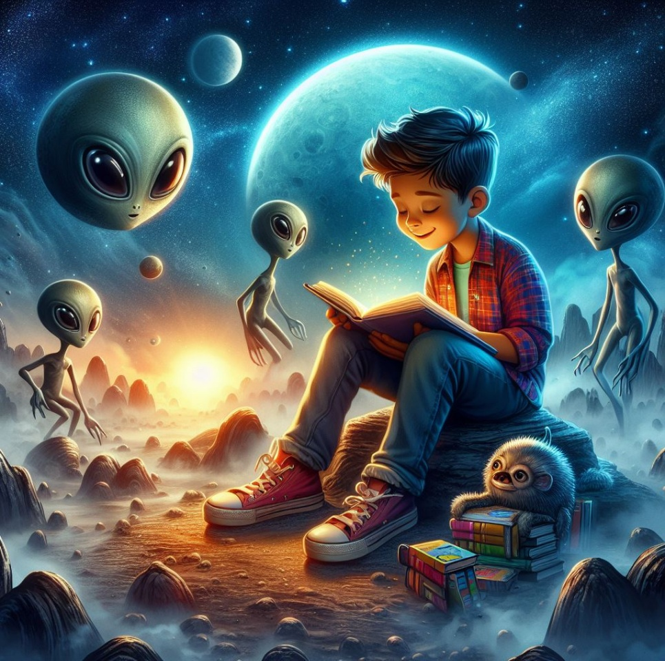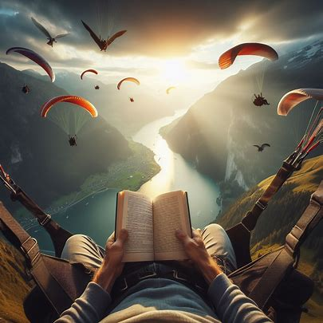

Where will your imagination take you…? 🎉

